Day 16

DIY

Q1. How to Configure fast, secure file transfers using Amazon S3 Transfer Acceleration

Background:

Amazon S3 Transfer Acceleration is a bucket-level feature that enables fast, easy, and secure transfers of files over long

distances between your client and an S3 bucket. Transfer Acceleration is designed to optimize transfer speeds from across the world into S3 buckets. Transfer Acceleration takes advantage of the globally distributed edge locations in Amazon CloudFront. As the data arrives at an edge location, the data is routed to Amazon S3 over an optimized network path.

Solution-

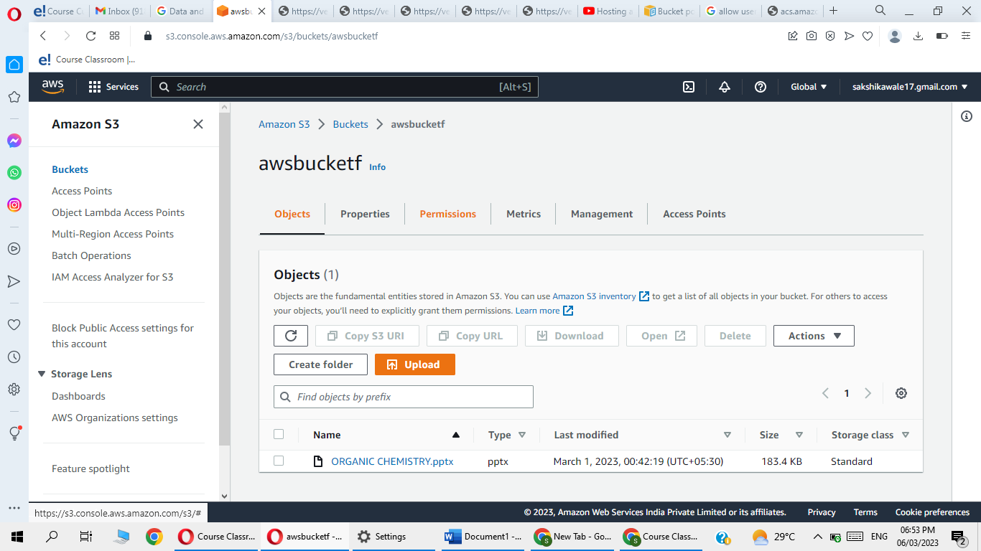

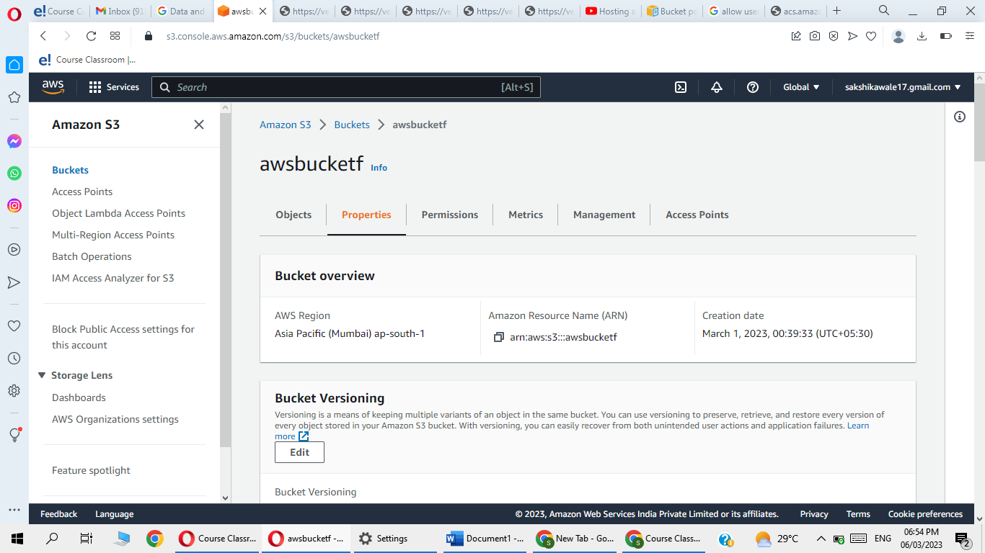

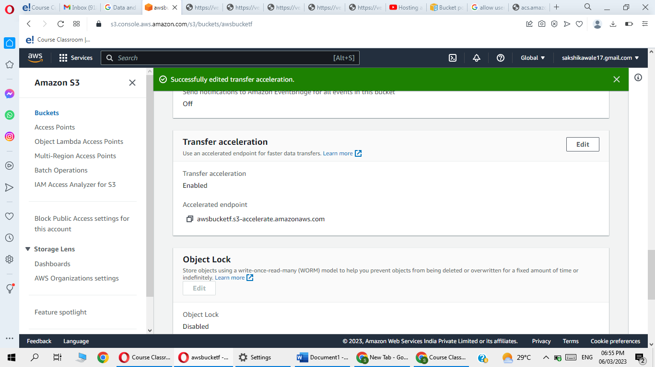

Q2 Using Requester Pays buckets for storage transfers and usage

Objective:

With Requester Pays buckets, the requester instead of the bucket owner pays the cost of the request and the data

download from the bucket. The bucket owner always pays the cost of storing data.

Problem Statement:

Configure buckets to be Requester Pays buckets when

you want to share data but not incur charges

associated with others accessing the data

Solution-

